**Title**

**AA AA1, BB BB2, CC CC3\***

1. *Department aa, Faculty bbb, Universitas cccc, City, Province, Postal Code, Country;*
2. *Department aa, Faculty bbb, Universitas cccc, City, Province, Postal Code, Country;*
3. *Department aa, Faculty bbb, Universitas cccc, City, Province, Postal Code, Country.*

*Correspondence: xxx@yyy.com

Received Date: Revised Date: Accepted Date:

**ABSTRACT**

The abstract for this journal is written in a single paragraph and in a concise manner. References in abstract should be avoided. Also, non-standard or uncommon abbreviations should be avoided, but if deemed necessary they must be defined at their first mention within the abstract. The abstract should at least contain these elements. **Background**: Provide a clear explanation of the context of the study and state the aim of the study in 1–6 sentences. Furthermore, please provide some brief literature review of the relevant studies. **Methods**: This element should describe the general procedures or technique, data collection technique, and analytical methods. Likewise, if the study is literature review, then author should state the theoretical component. **Finding:** Summarize the main findings, including specific effect sizes and their statistical significance, if possible. Include (if relevant) the number of participants in each group, the primary outcome for each group, and any significant adverse events or side effects. Also, please explain relation between your theory and your result in your article. **Conclusion**: In 1–2 sentences, state the principal conclusions, emphasizing new and important aspects of the study or observations in aspect of your research.

**KEYWORDS:** keyword 1; keyword 2; keyword 3.

**1. Introduction**

Provide an adequate background, context of the problems based on the literature review. State the **objectives of the study** and emphasize the **originality (state of the art)**. The first part should contain a broader **context**, followed by more specific issues that become the study's focus. **There is no theoretical background (literatur review) section** in this manuscript. However, author must input the theoretical background in the Introduction Section. Theoretical background contains relevant studies and theories to the research context and serves as the basis of study and the temporary hypothesis or assumption. The theory can be informed through scientific articles, articles in journals, textbooks, or other respected sources of scientific writing. This theory will be used to provide the state of the art of your manuscript from research problems that have been proposed. After the theories are mentioned and discussed, you need to form a problem that show why this manuscript is **important** and **existing gaps.** You must write **the purpose of the manuscript,** which should be presented in a narrative using effective sentences. The formulation of the hypotheses should be based on the theoretical review and, as far as possible, be expressed in terms of one-tailed direction.

Abbreviations and acronyms should be spelled out at first mention. Species names should be in italics. Manuscripts must include a list of references, which should include only sources that are cited in the text. The accuracy and completeness of references and citations are the responsibility of the author(s). Please follow this citation style: Citation should be in following style: (Julio, 2018), (Ahmed & Saleh, 2017), (Gretz et al., 2017), (Fowler et al., 2018a; Fowler et al., 2018b), (Joe et al., 2014; Dexler, 2016; Adams, 2018).

The figure number and caption should be typed below the illustration in 10 pt and centered. If the figures get on other sources, write the name of source below the figures, left justified. The figures on your manuscript must send separately from your manuscript with high resolution. Graphics using Office software such as Microsoft Excel can be provided in their original format to maintain image quality. Other line graphics/illustrations should be provided in EPS format with a resolution of at least 600 dpi to prevent the appearance of uneven lines. Images must have a minimum width of 160 mm and an appropriate resolution (Fig. 1).

Fig. 1. Percentage of waste and leftover food produced in each stage of supply

(Hanson et al., 2015)

**2. Methods**

The author uses methods to answer the existing research problem. This section describes the overall research methods used in the research process. Provide sufficient detailed methods to allow the work to be reproduced. Methods already published should be indicated by a reference; only relevant modifications should be described. Author should include the reason behind the decision of location and time of the research. It should be in line with the ontological and epistemological aspects of the research. For the research location, author may add a map of the research area as long as it follows the cartographical standard. Using map from a third party should be avoided. See the example of research location map in Fig. 2.

The method must clear with description of the materials used in the study, the population and sample or key infromant, research variables, data soruces, the general procedures and techniques, the data collection technique, the analysis method, and data presentation. For research using experiments, the method should also include the design or the setup of the research. For article review, author should also describe the theoretical components. For qualitative method, author may include the methods in data condensation (for example, coding system), data display (how the data is presented which allow for drawing conclusion), and conclusion drawing. For quantitative method, author may include the methods in sampling, data collection, and data analysis.

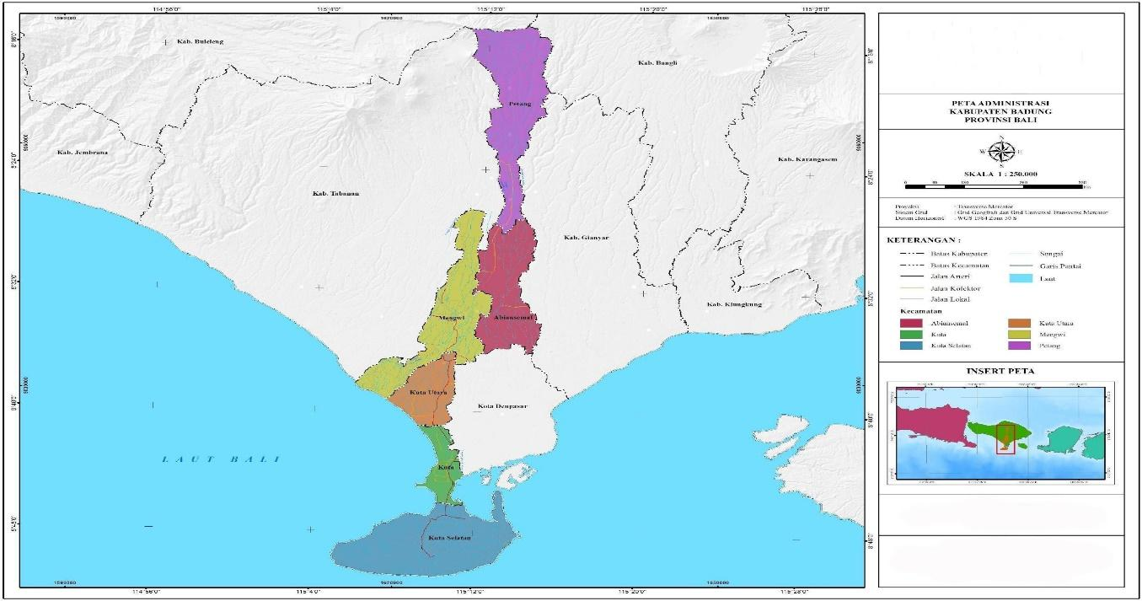

Fig. 2. Research location

**3. Results and Discussion**

*3.1 Sub-section headings*

Result and discussion contain results obtained by the author during the research. The results of the research submitted in advance as a whole, which continues by doing the process of discussion. Result and discussion of your manuscript also interconnected with your theory that used. The discussion is presented systematically from **general, then leads to the specific**. Presentation of the research can be done with the help of tables, drawings/graphs, maps/plans, and schemes.

Results should be clear and concise. Discussion must explore the significance of the results of the work. Adequate discussion or comparison of the current results to the previous similar published articles is recommended to show the present research's positioning (if available) (fig. 3).

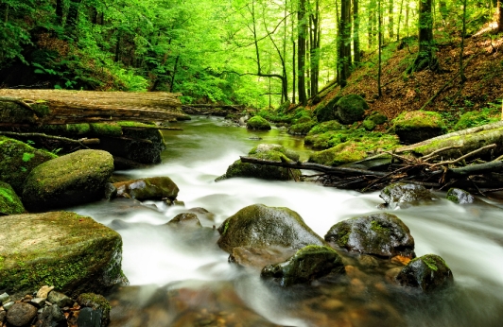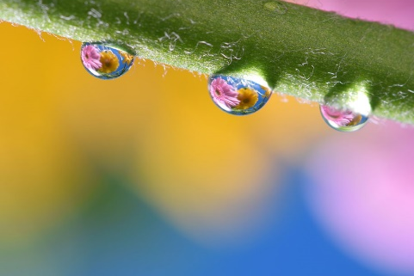

Fig. 3 (a) First picture; (b) Second picture

(Hanson et al., 2015)

Result text - Result text - Result text - Result text - in Figure 1. Result text -Result text - Result text - Result text - Result text - Result text -Result text - Result text - Result text - Result text - Result text -Result text - Result text - Result text - Result text - Result text -Result text - Result text - Result text - Result text (Table 1).

Table 1. Number of receptors in each container

| An example of a column heading | Column A (*t*) | Column B (*t*) |
| --- | --- | --- |
| And an entry | 1 | 2 |
| And another entry | 3 | 4 |
| And another entry | 5 | 6 |

(Hanson et al., 2015)

Mathematical equations, variables, and anything representing a value should be italicized. Formulae should be numbered consecutively throughout the manuscript as Eq. 1. In cases where the derivation of formulae has been abbreviated, it is of great help to the reviewers if the full derivation can be presented on a separate sheet (not to be published). Formulae should be centred and numbered. In this case the number will appear in the right margin.

(Eq. 1)



Result and Discussion text - Result and Discussion text- Result and Discussion text - Result and Discussion text- Result and Discussion text - Result and Discussion text Result and Discussion text - Result and Discussion text

**4. Conclusions**

This section presents the main conclusions of the study. They should be presented in concise, clear, and compact sentences based on the results and discussions, in the form of paragraphs (not with bullet points or numbering); clarify the findings of the study as a synthesis of the results of the data analysis and discussion; and highlight original findings that contribute to the development of science. The main conclusion of the study may be presented in a short conclusions section, which may stand-alone. It should not repeat the results, instead provide significant findings and contribution of the study and the issue of this aim and scope this journal.

Conclusion text - Conclusion text - Conclusion text - Conclusion text - Conclusion text - Conclusion text - Conclusion text - Conclusion text - Conclusion text - Conclusion text - Conclusion text - Conclusion text - Conclusion text - Conclusion text - Conclusion text - Conclusion text - Conclusion text - Conclusion text - Conclusion text - Conclusion text - Conclusion text - Conclusion text - Conclusion text - Conclusion text - Conclusion text - Conclusion text - Conclusion text

**Acknowledgement**

Acknowledgments are inserted at the end of the manuscript after the conclusion section. Individuals who assisted with the research should be listed here (e.g., providing language assistance, writing assistance, proofreading articles, etc.). Use unnumbered section titles for Acknowledgments, similar to the titles References, Author Contribution, Funding, Ethical Review Board Statement, Informed Consent Statement, Data Availability Statement, Conflict of Interest, and explanations related to Open Access.

**Author Contribution**

Each author is expected to make substantial contributions to the design or design of the work; or to the acquisition, analysis, or interpretation of the data; or to the creation of new software used in the work; or to the drafting or substantive revision of the work; and to the approval of the version submitted (and the version substantially modified by the staff of the journal, which includes the contribution of the author to the work).

For each article with several authors, a short paragraph specifying their individual contributions must be provided in the **Title Page**. The following statements should be used "Conceptualization, X.X. and Y.Y.; Methodology, X.X.; Software, X.X.; Validation, X.X., Y.Y. and Z.Z.; Formal Analysis, X.X.; Investigation, X.X.; Resources, X.X.; Data Curation, X.X.; Writing – Original Draft Preparation, X.X.; Writing – Review & Editing, X.X.; Visualization, X.X.; Supervision, X.X.; Project Administration, X.X.; and Funding Acquisition, Y.Y.”. Please turn to the CRediT taxonomy (<https://casrai.org/CRediT/>) for an explanation of the term and background of the CRediT.

**Funding**

Please add: “This research received no external funding” **OR** “THE NAME OF FUNDER funded this research, grant number XXX” **OR** “XXX funded the APC.” Check carefully that the details are accurate, including the use of the standard spelling of funding agency names and the formal grant number.

**Ethical Review Board Statement**

In this section, author should add the Institutional Review Board Statement and its approval number if relevant to the study. Author might exclude this statement if the study did not require ethical clearance. Please add, “The study was conducted in accordance with the NAME OF LAW and approved by the Institutional Review Board (or Ethics Committee) of NAME OF INSTITUTE (protocol code XXX and date of approval).” **OR** “Ethical review and approval were waived for this study due to REASON (please provide a detailed justification).” **OR** “Not applicable” for studies not involving humans or animals or not concerning public health and safety.

**Informed Consent Statement**

Any research article describing a study involving humans should contain this statement. Please add, “Informed consent was obtained from all subjects involved in the study.” **OR** “Informed consent was waived due to REASON (please provide a detailed justification).” **OR** “Not applicable.” for studies not involving humans (author might also exclude this statement if the study did not involve humans). Written informed consent for publication must be obtained from research participants who can be identified (including by the participant themselves). Please state, “Written informed consent has been obtained from the participant(s) to publish this paper,” if applicable.

**Data Availability Statement**

We encourage all authors of articles published in this journal to share their research data. This section provides details regarding where data supporting reported results can be found, including links to publicly archived datasets analyzed or generated during the study. A statement is still required when no new data are created or unavailable due to privacy or ethical restrictions.

**Conflicts of Interest**

Declare conflicts of interest or state, “The authors declare no conflict of interest.” Authors must identify and declare any personal circumstances or interests that may be perceived as inappropriately influencing the representation or interpretation of reported research results. Any role of the funders in the design of the study; in the collection, analysis, or interpretation of data; in the writing of the manuscript; or in the decision to publish the results must be declared in this section. If there is no role, please state, “The funders had no role in the design of the study; in the collection, analyses, or interpretation of data; in the writing of the manuscript; or in the decision to publish the results”.

**Open Access**

©2024. The author(s). This article is licensed under a Creative Commons Attribution 4.0 International License, which permits use, sharing, adaptation, distribution and reproduction in any medium or format, as long as you give appropriate credit to the original author(s) and the source, provide a link to the Creative Commons license, and indicate if changes were made. The images or other third-party material in this article are included in the article’s Creative Commons license, unless indicated otherwise in a credit line to the material. If material is not included in the article’s Creative Commons license and your intended use is not permitted by statutory regulation or exceeds the permitted use, you will need to obtain permission directly from the copyright holder. To view a copy of this license, visit: <http://creativecommons.org/licenses/by/4.0/>

**References**

The reference list contains full details of all the references cited in the text of the article. It is recommended that they should be from the last 5-10 years and listed in alphabetical order following the American Psychological Association Referencing Style (7th Edition); refer to <https://apastyle.apa.org/products/publication-manual-7th-edition>.

* Meanwhile, references should be in APA style constructed with Mendeley. For more information, please check <https://open.mendeley.com/use-citation-style/apa>
* References should be arranged in alphabetical order
* For the research article manuscript, the number of reference should be **more than 30 references**
* For the review article manuscript, the reference should be a minimum of **50 references**
* The references must have been published within the last 3-5 years unless it is still strongly relevant to the study and no recent publication covers the niche.
* References from scientific articles must be published by reputable journal publishers (Scopus-indexed and WOS journals are preferred)
* 80% of the references must be comprised of primary sources/journal articles. Only references related to the theme of the writing may be referred to, and all references cited in the manuscript should allow anyone to access it.
* All the listed references must be cited in the text and all text citations listed in the reference list.
* DOI for each reference should be provided if available. The use of a DOI is highly recommended as it is guaranteed to never change, so you can use a permanent link to any electronic article.
* Although authors are not obliged to, it is suggested that they use reference manager programs such as Mendeley or Zotero.
* References (books, journal articles, online news, etc.) which published in non English Language, do not need to be translated into English
* Authors are **forbidden** to cite any article that has been previously published in this journal.
* Authors are **forbidden** to cite his/her article published in this journal or elsewhere unless it is still strongly relevant to the study and no recent publication covers the niche.

**JOURNAL ARTICLE**

Grady, J. S., Her, M., Moreno, G., Perez, C., & Yelinek, J. (2019). Emotions in storybooks: A comparison of storybooks that represent ethnic and racial groups in the United States. *Psychology of Popular Media Culture*, *8*(3), 207-217. <https://doi.org/10.1037/ppm0000185>

***Parenthetical citation:*** (Grady et al., 2019)

***Narrative citation:*** Grady et al. (2019)

**JOURNAL ARTICLE WITH AN ARTICLE NUMBER**

Jerrentrup, A., Mueller, T., Glowalla, U., Herder, M., Henrichs, N., Neubauer, A., & Schaefer, J. R. (2018). Teaching medicine with the help of “Dr. House.” *PLoS ONE*, *13*(3), Article e0193972. <https://doi.org/10.1371/journal.pone.0193972>

***Parenthetical citation:*** (Jerrentrup et al., 2018)

***Narrative citation:*** Jerrentrup et al. (2018)

**JOURNAL ARTICLE WITH MISSING INFORMATION**

*Missing Volume Number*

Stegmeir, M. (2016). Climate change: New discipline practices promote college access. *The Journal of College Admission*, (231), 44-47. <https://www.nxtbook.com/ygsreprints/NACAC/nacac_jca_spring2016/#/46>

*Missing Issue Number*

Sanchiz, M., Chevalier, A., & Amadieu, F. (2017). How do older and young adults start searching for information? Impact of age, domain knowledge and problem complexity on the different steps of information searching. *Computers in Human Behavior*, *72*, 67-78. <https://doi.org/10.1016/j.chb.2017.02.038>

*Missing Page or Article Number*

Butler, J. (2017). Where access meets multimodality: The case of ASL music videos. *Kairos: A Journal of Rhetoric, Technology, and Pedagogy*, *21*, 1. <http://technorhetoric.net/21.1/topoi/butler/index.html>

***Parenthetical citation:*** (Butler, 2017; Sanchiz et al., 2017; Stegmeir, 2016)

***Narrative citation:*** Butler (2017), Sanchiz et al. (2017), and Stegmeir (2016)

**NEWSPAPER ARTICLE REFERENCES**

Carey, B. (2019, March 22). Can we get better at forgetting? *The New York Times*. <https://www.nytimes.com/2019/03/22/health/memory-forgetting-psychology.html>

Harlan, C. (2013, April 2). North Korea vows to restart shuttered nuclear reactor that can make bomb-grade plutonium. *The Washington Post*, A1, A4.

Stobbe, M. (2020, January 8). Cancer death rate in U.S. sees largest one-year drop ever. *Chicago Tribune*.

***Parenthetical citation:*** (Carey, 2019; Harlan, 2013; Stobbe, 2020)

***Narrative citation:*** Carey (2019), Harlan (2013), and Stobbe (2020)

**BOOK**

McKibbin, B. (2007). *Deep economy: The wealth of communities and the durable future*. Times Book/Henry Hold and Co.

**CHAPTER IN AN EDITED BOOK**

Pigg, K. E., & Bradshaw, T. K., (2003). Catalytic community development: A theory of practice for changing rural society. In D. L. Brown & L. E. Swanson (Eds.), *Challenges for rural America in the twenty-first century* (pp. 385-396). Pennsylvania State University Press.

***Parenthetical citation:*** (McKibbin, 2008; Pigg & Bradshaw, 2003)

***Narrative citation:*** McKibbin, 2008, and Pigg & Bradshaw, 2003

**CONFERENCE PRESENTATIONS AND PROCEEDING**

*Conference Presentations*

Evans, A. C., Jr., Garbarino, J., Bocanegra, E., Kinscherff, R. T., & Márquez-Greene, N. (2019, August 8–11). *Gun violence: An event on the power of community* [Conference presentation]. APA 2019 Convention, Chicago, IL, United States. <https://convention.apa.org/2019-video>

***Parenthetical citation:*** (Evans et al., 2019)

***Narrative citation:*** Evans et al. (2019)

*Abstract of a Conference Precentation*

Cacioppo, S. (2019, April 25–28). *Evolutionary theory of social connections: Past, present, and future* [Conference presentation abstract]. Ninety-ninth annual convention of the Western Psychological Association, Pasadena, CA, United States. <https://westernpsych.org/wp-content/uploads/2019/04/WPA-Program-2019-Final-2.pdf>

***Parenthetical citation:*** (Cacioppo, 2019)

***Narrative citation:*** Cacioppo (2019)

Conference *Proceedings published in a Journal*

*Conference proceedings published in a journal follow the same format as journal articles*

Duckworth, A. L., Quirk, A., Gallop, R., Hoyle, R. H., Kelly, D. R., & Matthews, M. D. (2019). Cognitive and noncognitive predictors of success. *Proceedings of the National Academy of Sciences, USA, 116*(47), 23499–23504. <https://doi.org/10.1073/pnas.1910510116>

***Parenthetical citation:*** (Duckworth et al., 2019)

***Narrative citation:*** Duckworth et al. (2019)

*Conference Proceedings published as a whole Book*

*Conference proceedings published as a whole book follow the same reference format as whole edited books.*

Kushilevitz, E., & Malkin, T. (Eds.). (2016). *Lecture notes in computer science: Vol. 9562. Theory of cryptography.* Springer. <https://doi.org/10.1007/978-3-662-49096-9>

***Parenthetical citation:*** (Kushilevitz & Malkin, 2016)

***Narrative citation:*** Kushilevitz and Malkin (2016)

*Conference Proceedings published as a Book Chapter*

*The format for conference proceedings published as an edited book chapter is the same as for edited book chapters.*

Bedenel, A.-L., Jourdan, L., & Biernacki, C. (2019). Probability estimation by an adapted genetic algorithm in web insurance. In R. Battiti, M. Brunato, I. Kotsireas, & P. Pardalos (Eds.), *Lecture notes in computer science: Vol. 11353. Learning and intelligent optimization* (pp 225-240). Springer. <https://doi.org/10.1007/978-3-030-05348-2_21>

***Parenthetical citation:*** (Bedenel et al., 2019)

***Narrative citation:*** Bedenel et al. (2019)

**All references must provide the link (example)**

Alamsyah, M. N. (2023, May). *A review of food waste management in Indonesia and best practice in various countries*. In AIP Conference Proceedings (Vol. 2683, No. 1). AIP Publishing. <https://doi.org/10.1063/5.0124861>

Feed W. M. (2017). *Feeding America West Michigan Marks Fourth Record Year*. Retrieved from <https://www.feedwm.org/2017/01/feeding-america-west-michigan-celebrates-fourth-record-year/>

Hanson, C., Lipinski, B., Friedrich, J., O'Connor, C., & James, K. (2015). *World Resources Institutes*. Retrieved from World Resources Institutes Blog:

<https://www.wri.org/insights/whats-food-loss-and-waste-got-do-climate-change-lot-actually>

International Energy Agency (IEA). (2014). *CO2 Emissions From Fuel Combustion (2014 edition).* Paris: OECD/IEA. Retrieved from

<https://www.pbl.nl/sites/default/files/cms/publicaties/pbl-2014-iea-co2-emissions-from-fuel-combustion-1971-2012-total-greenhouse-gas-emissions.pdf>.

Jeswani, H. K., Figueroa-Torres, G., & Azapagic, A. (2021). The extent of food waste generation in the UK and its environmental impacts. Sustainable Production and Consumption, *26*, 532-547. <https://doi.org/10.1016/j.spc.2020.12.021>

Kaplinsky, R., & Morris, M. (2000). *A handbook for value chain research.* Ottawa: International Development Research Center. Retrieved from <http://www.prism.uct.ac.za/Papers/VchNov01.pdf>.

Kusumowardani, N., Tjahjono, B., Lazell, J., Bek, D., Theodorakopoulos, N., Andrikopoulos, P., & Priadi, C. R. (2022). A circular capability framework to address food waste and losses in the agri-food supply chain: The antecedents, principles and outcomes of circular economy. Journal of Business Research, *142*, 17-31. <https://doi.org/10.1016/j.jbusres.2021.12.020>

Lafrati, S. (2016). The sustainability of food bank provision: What happens when demand outstrips supply? *Journal of Poverty and Social Justice, 23*(4), 307–10. <https://doi.org/10.1332/175982716X14689202610221>

Lipinski, B. (2015). By the Numbers: Reducing Food Loss and Waste. Retrieved from <https://www.wri.org/blog/2013/06/numbers-reducing-food-loss-and-waste>.

Martins, C. L., Melo, T., & Pato, M. V. (2016). Redesigning a food bank supply chain network, Part I: Background and mathematical formulation (No. 10). Schriftenreihe Logistik der Fakultät für Wirtschaftswissenschaften der htw saar*.* <http://hdl.handle.net/10419/145975>

Middleton, G., Mehta, K., McNaughton, D., & Booth, S. (2018). The experiences and perceptions of food banks amongst users in high-income countries: An international scoping review. Appetite, 698-708. <https://doi.org/10.1016/j.appet.2017.10.029>

Miles, M. B., Saldaña, J., & Huberman, A. M. (2019). *Qualitative Data Analysis: A Methods Sourcebook* (4th ed.). Sage Publications. ISBN: 9781506353081. <https://us.sagepub.com/en-us/nam/qualitative-data-analysis/book246128#resources>

Moxnes, E. (2009). Diffusion of System Dynamics. Presidential address Albuquerque 2009. Retrieved from <https://www.systemdynamics.org/assets/conferences/2009/proceed/papers/P1449.pdf>.

| **Biographies of Author(s)**    **AAAA AAAA,** Briefly describe the author's name, affiliation, latest education and area of ​​expertise in 1-2 paragraphs (maximum in 100 word).   * Email: * ORCID: * Web of Science ResearcherID: * Scopus Author ID: * Homepage:   **BBBB BBBB,** Briefly describe the author's name, affiliation, latest education and area of ​​expertise in 1-2 paragraphs (maximum in 100 word).   * Email: * ORCID: * Web of Science ResearcherID: * Scopus Author ID: * Homepage:   **CCCC CCCC**, Briefly describe the author's name, affiliation, latest education and area of ​​expertise in 1-2 paragraphs (maximum in 100 word).   * Email: * ORCID: * Web of Science ResearcherID: * Scopus Author ID: * Homepage: |
| --- |

**PAPER TEMPLATE**

**Preparation**. Please erase this part when editing the manuscript. This Journal has 2 types of manuscripts that Author should follow, namely Original Research article and Review article.

**Original Research Article (5000 to 6000 words, excluding references)**. A full-length original empirical research, mainly following this order: introduction, methods, results and discussion, conclusions, and references. Author is expected to provide an accurate description of the research and a clear explanation of the objective, and also a comprehensive discussion of the results.

**Review Article (5000 to 9000 words, excluding references)**. A comprehensive and critical, systematic, or bibliometric literature review (including organizing, integrating, and evaluating) of the latest published research and meta-analysis.

Author is expected to fill the **Self-Judgement Checklist** before submission. This to ensure the manuscript follows the guideline and have completed all aspects referred within the guideline.

Authors are also expected to fill a **Covering Letter** to the editor.

Manuscripts that have the potential to be published will go through a **double-blinded process** so that **author information will be removed** when submitting the manuscript to reviewers.